**Emerging Technology About Nano-Technology.**

**A Seminar REPORT**

***Submitted by***

***NAME*  *ID No***

1. **Demeke Ayehunie……..……….…………TEE/0095/10**
2. **Tadesse Zelalem…………………………..TEE/0120/10**

***Under the guidance of***

Frehiwot Mekuriaw. (MSc)



**DEPARTMENT OF SOFTWARE ENGINEERING**

INISTITUTE OF TECHNOLOGY

**DEBREMARKOS UNIVERSITY**

DEBRE MARKOS, ETHIOPIA

February, 2014

Table of Contents

1. Nano Technology 3

1.1. Introduction 3

1.2 History of Nanotechnology 3

1.3 Why Nanotechnology develop 4

1.4 Application of Nanotechnology 4

1.5 Challenges of Nano Technology 7

References 7

Table of figures

Figure 1 Nano Technology in cancer therapy 6

Figure 2 Nano Technology in computer chips 7

Figure 3 Ensuring Food Safety in Nano Technology 8

# Nano Technology

## Introduction

Nanotechnology deals with the understanding and control of matter at dimensions between approximately 1 and 100 nanometers.

More specifically, nanotechnology is the imaging, modeling, measuring, design, characterization, production, and application of structures, devices, and systems by controlled manipulation of size and shape at the Nanoscale (atomic, molecular, and macromolecular scale) that produces structures, devices, and systems with at least one novel/superior characteristic or property. The term Nanoscale is the scale of **Nanomaterial** that having one or more dimensions of the order of 100 [nm](https://ec.europa.eu/health/scientific_committees/opinions_layman/glossary/mno/nanometre.htm) or less. So nanotechnology is the study of Nano since. But different researchers give different definition. [4]

According to the U.S. Environmental Protection Agency (EPA), nanotechnology is defined as “the creation and use of structures, devices, and systems that have novel properties and functions because of their small size.

Nanotechnology Initiative (NNI, 2010) describes nanotechnology as “the understanding and control of matter at dimensions between approximately 1 and 100 nm, where unique phenomena enable novel applications.

Generally Nanotechnology is the study and application of extremely small things. So it is hard to imagine just how small technology is. Nanotechnology involves the ability to see and to control individual atoms and molecules.

## History of Nanotechnology

Human dreams and imagination often give rise to new science and technology. Nanotechnology, a 21st century frontier, was born out of such dreams. it dramatically increased during the industrial revolution. The study of nanoparticles is not new.

The concept of a ‘‘nanometer’’ was first proposed by Richard Zsigmondy, the 1925 Nobel Prize Laureate in chemistry. He coined the term nanometer explicitly for characterizing particle size and he was the first to measure the size of particles such as gold colloids using a microscope.

During the 1959 American Physical Society meeting at Caltech, he presented a lecture titled,  
‘‘There’s Plenty of Room at the Bottom’’, in which he introduced the concept of manipulating matter at the atomic level. This novel idea demonstrated new ways of thinking and Feynman’s hypotheses have since been proven correct. It is for these reasons that he is considered the father of modern nanotechnology.

Almost 15 years after Norio Taniguchi, was the first to use ‘‘Nano- technology’’ to describe semiconductor processes that occurred on the order of a nanometer.

The beginning of the 21st century saw an increased interest in the emerging fields of Nano science and nanotechnology. President George Bush signed into law the 21st Century Nanotechnology Research and Development. The legislation made nanotechnology research a national priority and created the National Technology Initiative (NNI).Today, the NNI is managed within a framework at the top of which is the President’s Cabinet-level National Science and Technology Council (NSTC) and its Committee on Technology. [1]

**Future of nanotechnology**

In a timeframe of approximately half a century, nanotechnology has become the foundation for remarkable industrial applications and exponential growth. For example, in the pharmaceutical communities of practice, nanotechnology has had a profound impact on medical devices such as diagnostic biosensors, drug delivery systems, and imaging probes. In the food and cosmetics industries, use of nanomaterials has increased dramatically for improvements in production, packaging, shelf life, and bioavailability. [3]

## Why Nanotechnology develop

Nanotechnology is hailed as having the potential to increase the efficiency of energy consumption, help clean the environment, and solve major health problems. It is said to be able to massively increase manufacturing production at significantly reduced costs. Products of nanotechnology will be smaller, cheaper, lighter yet more functional and require less energy and fewer raw materials to manufacture, claim nanotech advocates.

## Application of Nanotechnology

Nanotechnology is used in different area for different purpose. Some of these are:-

**Bio nanotechnology (Medicine)**

The term bio nanotechnology refers to the combination of ideas, techniques, and sciences of biology and nanotechnology. More specifically, Nano biotechnology refers to the application of Nanoscale objects for biotechnology while bio nanotechnology refers to the use of biological components in nanotechnology.[4]

The most prominent intersection of nanotechnology and biology is in the field of [Nano medicine](https://en.wikipedia.org/wiki/Nanomedicine), where the use of nanoparticles and Nano devices has many clinical applications in delivering therapeutic drugs, monitoring health conditions, and diagnosing diseases. Being that much of the biological processes in the human body occur at the cellular level, the small size of nanomaterial’s allows for them to be used as tools that can easily circulate within the body and directly interact with intercellular and even intracellular environments. A common application of Nano medicine is in therapeutic drug delivery, where nanoparticles containing drugs for therapeutic treatment of disease are introduced into the body and act as vessels that deliver the drugs to the targeted area. [2]

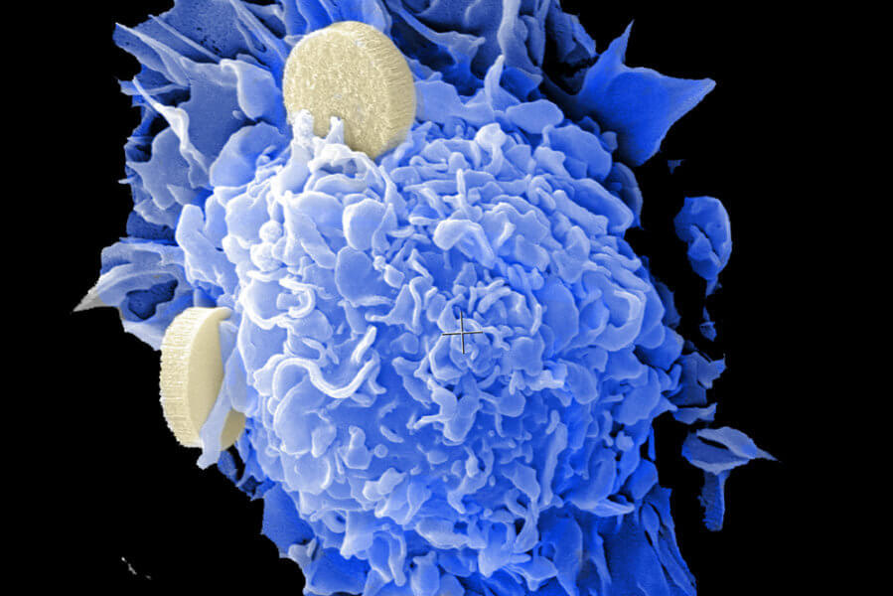

Figure 1 Nano Technology in cancer therapy

**Nanotechnology in Electronics (Nano electronics)**

Nano electronics offers you smaller faster and more portable systems. It increases the capabilities of electronic devices, components, and integrated systems and enhances the density of memory chips to manage and store larger amounts of data and information.

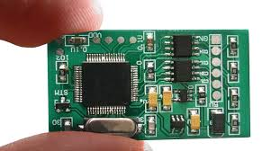

Figure 2 Nano Technology in computer chips

**Food Industry**

Food nanotechnology is an area of emerging interest and opens up a whole universe of new possibilities for the food industry. The basic categories of nanotechnology applications and functionalities currently in the development of food packaging include: the improvement of plastic materials barriers, the incorporation of active components that can deliver functional attributes beyond those of conventional active packaging, and the sensing and signaling of relevant information. Nano food packaging materials may extend food life, improve food safety, alert consumers that food is contaminated or spoiled, repair tears in packaging, and even release preservatives to extend the life of the food in the package. Nanotechnology applications in the food industry can be utilized to detect bacteria in packaging, or produce stronger flavors and color quality, and safety by increasing the barrier properties. [3]



Figure 3 Ensuring Food Safety in Nano Technology

**Nanotechnology in vehicle manufacturing**

**Nanotechnology promises to benefit many different aspects of industry. The automotive industry is certainly no exception. Nano-enhanced materials are already beginning to improve the performance and cost-effectiveness of vehicles, and this effect will only increase in the coming years, as harder, stronger, lighter nanomaterial’s become commercially available.**

## ****Challenges of Nano Technology****

The most immediate challenge in nanotechnology is that we need to learn more about materials and their properties at the Nanoscale. Universities and corporations across the world are rigorously studying how [atoms](https://science.howstuffworks.com/atom.htm) fit together to form larger structures. We're still learning about how quantum mechanics impact substances at the Nanoscale.

## **References**

1. National Nanotechnology Initiative (NNI). National Science and Technology Council. Committee on Tech- nology, Subcommittee on Nanoscale Science, National Technology Initiative Strategic Plan, [www.nano.gov](http://www.nano.gov) (2011, accessed 4 February 2022).

2. IOM (Institute of Medicine) Nanotechnology in food products: Workshop Summary Washington, DC: The National Academies Press; 2009Available from: <http://www.nap.edu/openbook.php?record_id=12633>(Accessed February 5 , 2022) [[Google Scholar](https://scholar.google.com/scholar_lookup?title=Nanotechnology+in+food+products:+Workshop+Summary&publication_year=2009&)]

3. Dingman J. Nanotechnology: its impact on food safety. (Guest Commentary) J Environ Health. 2008 Jan.